Salvador Dali is one of my favorite artists. I love Dali and his works because of his appreciation of the woman’s body, color, surrealism, and being yourself in raw form. When I was a senior in high school, I was in AP art. My concentration for the year was surrealism. Of course, through my studying of works of surrealism, I discover the father of surrealism, Salvador Dali. I studied him and his works of art throughout that year, that is why when I saw a Dali piece in the Quick Arts Center I was almost pulled towards it with memories and excitement.
This piece “Lincoln in Dalivison” expresses many different means all in one. When you are close to the work, it shows many different details. The first noticeable detail is a naked woman standing in the center of the painting. She seems to be looking out a window to the outside world. The outside is vibrant and seems to be full of live. In contrast to the outside, the inside is dull and dark with the only light/color coming from the window to the outside. Another thing that I noticed about the outside is in the top, one of Dali’s works is pieced in there carefully. That work is St John who is represented by an eagle and was able to look straight into the sun. In this work, he is represented by an eagle in front of the sun. St John is the saint of the sick, nurses, firefighters, alcoholics, and hospitals. It is possible that this woman, who is facing out the window is one of or is yearning to be one of these things.
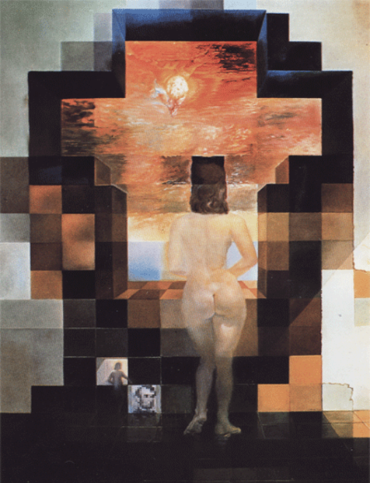
Then I started to think a little bit more than what’s in plain sight, and thought more about the details flowing together to tell a story. The fact that the woman is naked represents her vulnerability, her raw form and/or her passion. I believe that the woman is showing that she truly wants to be one of these things or is in love with someone. The inside can represent the person she is with now, dark and dull. The outside can represent the person she wants to be with, vibrant and full of live. If St John is looking over this person they may be sick, a nurse, firefighter, alcoholic, and/or in a hospital. I couldn’t help to wonder, who is the woman sick of or who is the woman in love with? When you pull away from the image it turns into Lincoln with an optical illusion. After discovering this I couldn’t help to think, I wonder what Lincoln’s wife looked like, and sure enough, she was pale and has the same hair style as the woman in the painting.

